3.Inserting and retrieving data from database able using SQLDML commands.

1.Select or Create a Database
create database test_db;
use test_db;
show databases;

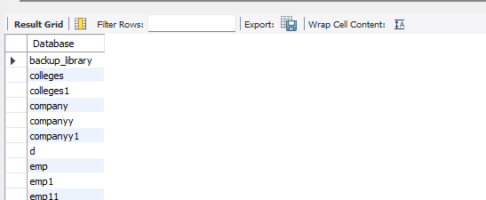

2.Create a Table(if not exists)
create table users (
id int auto_increment primary key,
name varchar(100),
email varchar(100)
);
desc users;

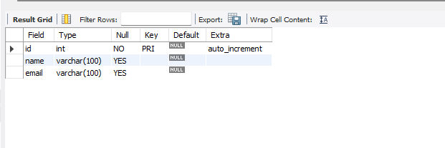
3.Insert Data into the Table
insert into users(name,email)
values('Harry','harry44@example.com'),
('John','john32@example.com');

4.Retrieve Data from the Table
select*from users;

